Truncated Cube

Definition
# Source: AI Source: Provided by: [Data Path: Persons Table -> ID Column: 1, Name_En Column: Motasem Essam] -> From: [ChatGPT] on [7/25/2026]
A Truncated Cube is a three-dimensional polyhedron formed by cutting off the eight vertices of an original cube using planes.
The truncation process creates eight new triangular faces while modifying the original six square faces into octagonal faces.
A uniformly truncated cube is an Archimedean solid.

Geometric Structure
# Source: AI Source: Provided by: [Data Path: Persons Table -> ID Column: 1, Name_En Column: Motasem Essam] -> From: [ChatGPT] on [7/25/2026]
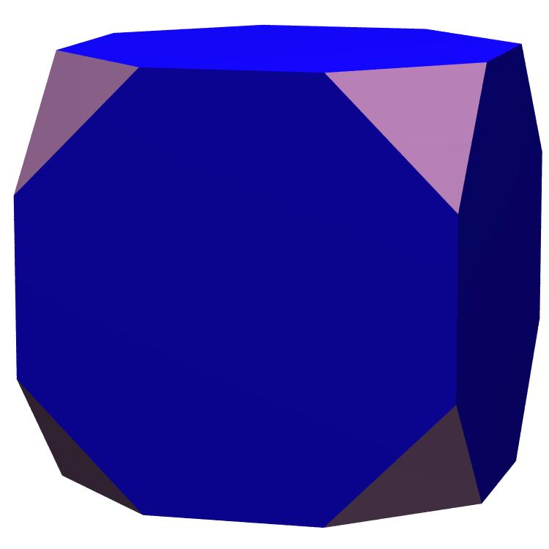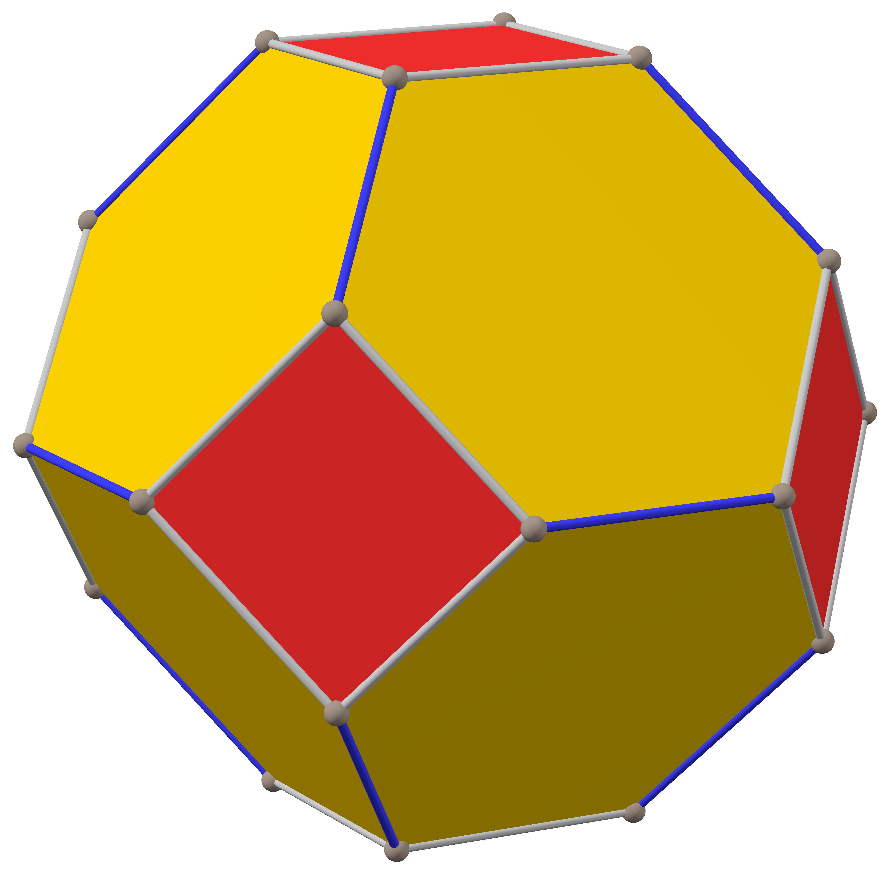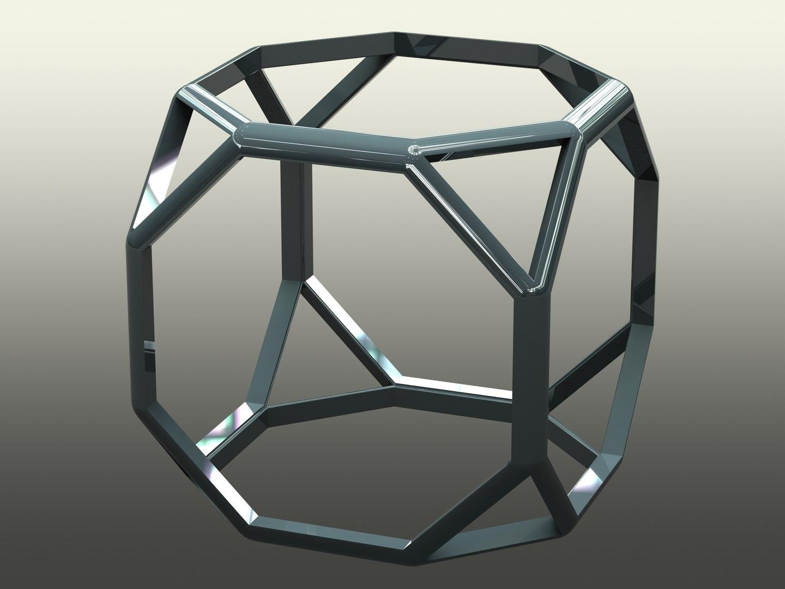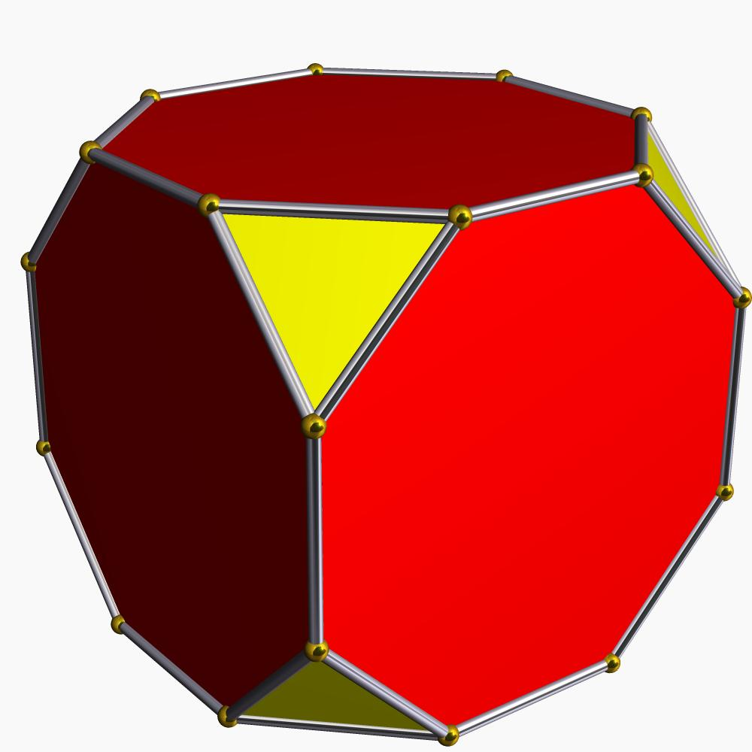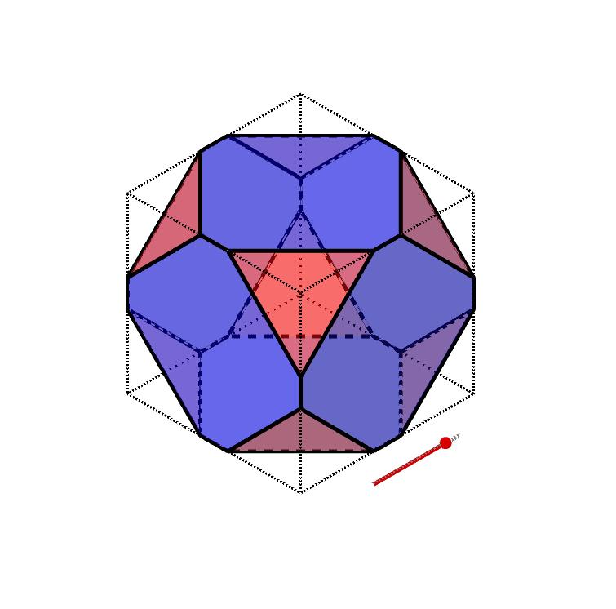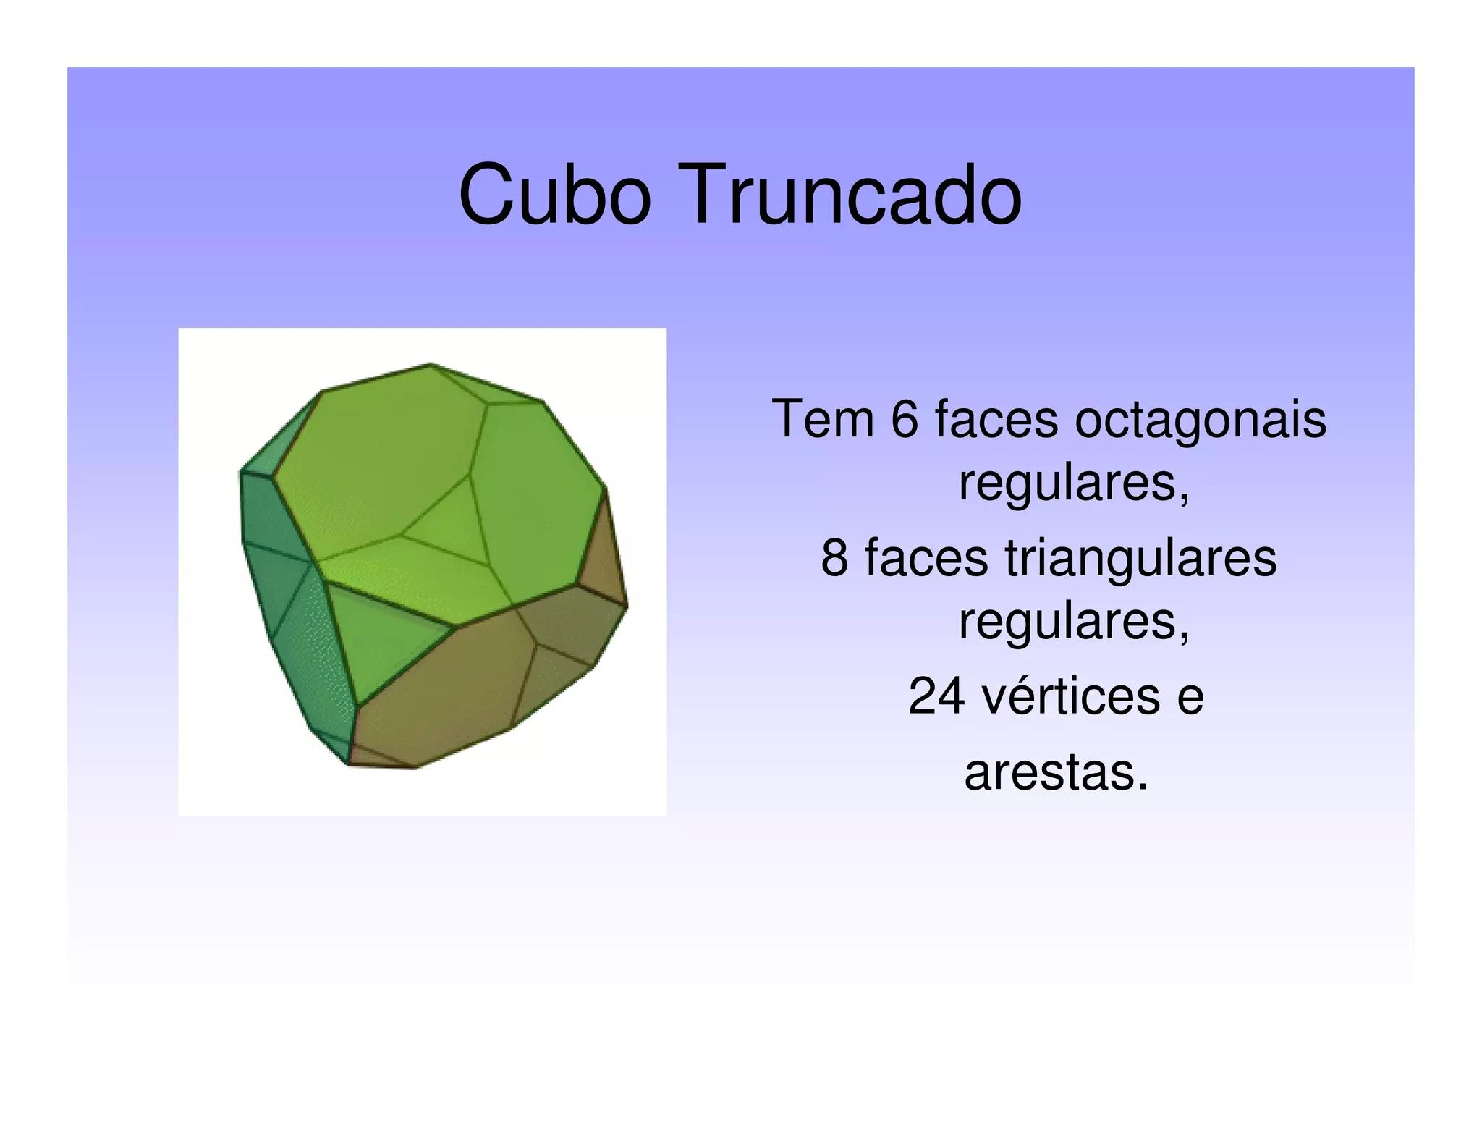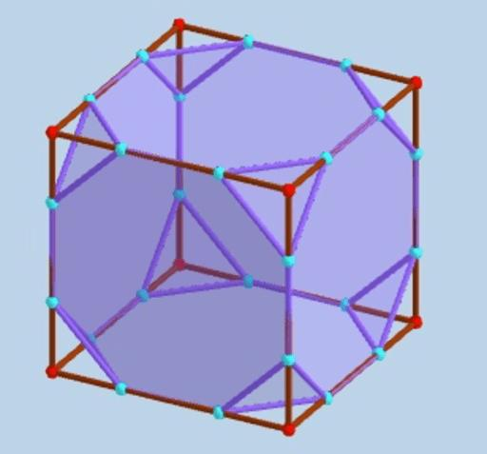
A truncated cube consists of:
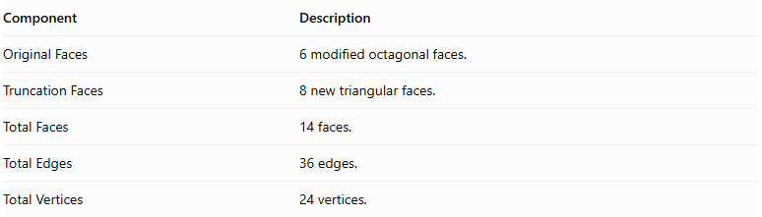
Component | Description
Original Faces | 6 modified octagonal faces.
Truncation Faces | 8 new triangular faces.
Total Faces | 14 faces.
Total Edges | 36 edges.
Total Vertices | 24 vertices.

Face Composition
# Source: AI Source: Provided by: [Data Path: Persons Table -> ID Column: 1, Name_En Column: Motasem Essam] -> From: [ChatGPT] on [7/25/2026]
The truncated cube contains two types of polygonal faces:
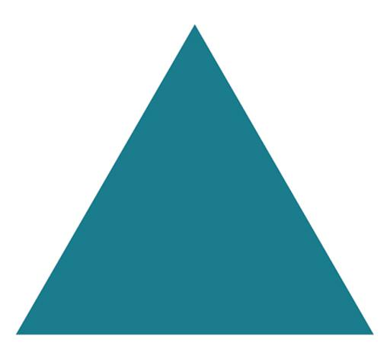

Triangular Faces
# Source: AI Source: Provided by: [Data Path: Persons Table -> ID Column: 1, Name_En Column: Motasem Essam] -> From: [ChatGPT] on [7/25/2026]
- Number: 8
- Shape: Equilateral triangles.
- Origin: Created by truncating the eight original vertices.
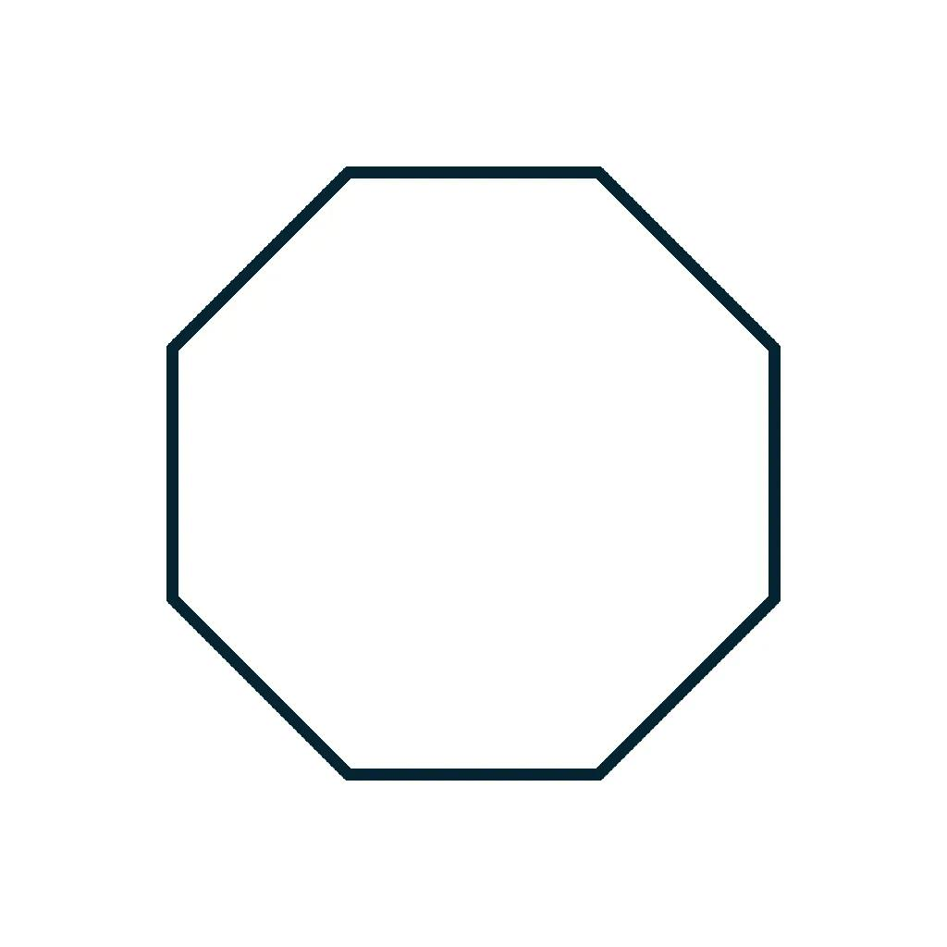

Octagonal Faces
# Source: AI Source: Provided by: [Data Path: Persons Table -> ID Column: 1, Name_En Column: Motasem Essam] -> From: [ChatGPT] on [7/25/2026]
- Number: 6
- Shape: Regular octagons.
- Origin: Modified from the six original square faces.

Mathematical Properties
# Source: AI Source: Provided by: [Data Path: Persons Table -> ID Column: 1, Name_En Column: Motasem Essam] -> From: [ChatGPT] on [7/25/2026]
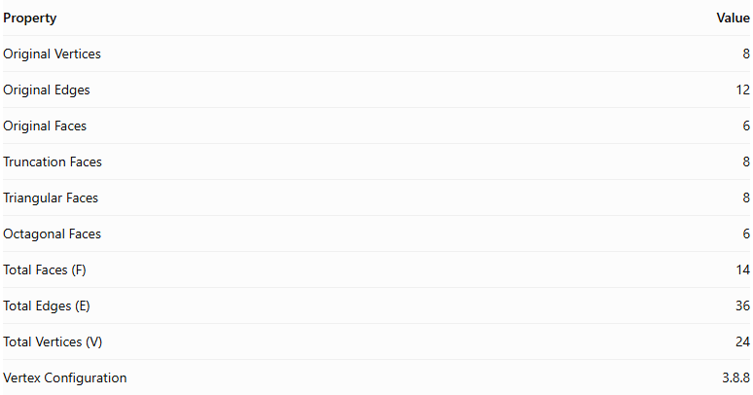
Property | Value
Original Vertices | 8
Original Edges | 12
Original Faces | 6
Truncation Faces | 8
Triangular Faces | 8
Octagonal Faces | 6
Total Faces (F) | 14
Total Edges (E) | 36
Total Vertices (V) | 24
Vertex Configuration | 3.8.8
Euler's Formula:
$$V-E+F=2$$
Substituting:
$$24-36+14=2$$
Therefore, the truncated cube satisfies Euler's formula.

Key Points
# Source: AI Source: Provided by: [Data Path: Persons Table -> ID Column: 1, Name_En Column: Motasem Essam] -> From: [ChatGPT] on [7/25/2026]
- It originates from a regular cube.
- All eight original vertices are truncated.
- It has 8 equilateral triangular faces and 6 regular octagonal faces.
- It contains 36 edges and 24 vertices.
- It is an Archimedean solid when uniformly truncated.
- Its faces are regular polygons.

Conclusion
# Source: AI Source: Provided by: [Data Path: Persons Table -> ID Column: 1, Name_En Column: Motasem Essam] -> From: [ChatGPT] on [7/25/2026]
The Truncated Cube is an Archimedean solid formed by uniformly truncating the eight vertices of a regular cube. It consists of eight equilateral triangular faces and six regular octagonal faces, with a total of 14 faces, 36 edges, and 24 vertices.

